1. Behind us is the old city in grey monotone colours with rain showers.  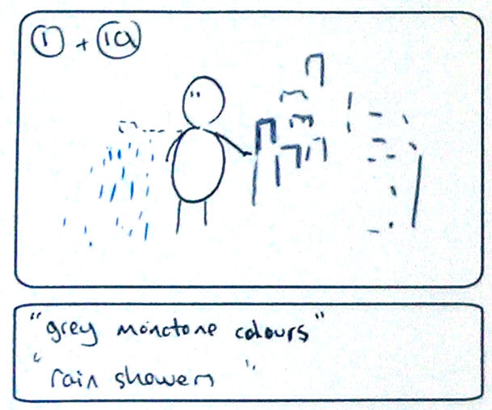  interaction: make rain from hands  graphics: city, rain  sound: wind blowing / whoosh, twinkling/windchime | 2. As we go forwards towards the main city with its vibrant lifestyle and colourful cityscape.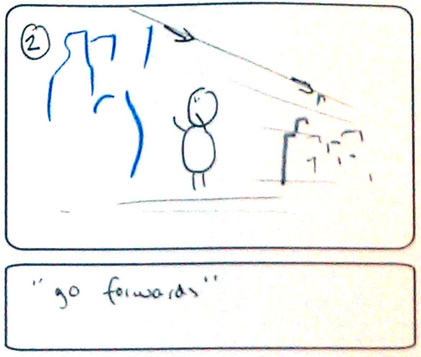  interaction: point forward, to move forward  graphics:color cityscape  sound: | 3. To the right you can see the flowers growing and blossoming up the walls.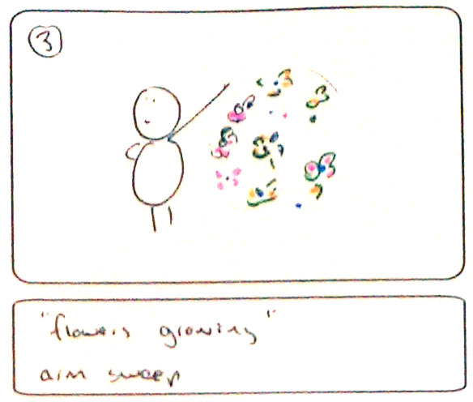  interaction: arm sweep leaves flowers in its wake  graphics: 4-5 different flowers  sound: growing slow motion crunching wildlife sound, blossoming - speeds up
4. To the left we have the colour wheel of happiness informing everybody of the colour of the day today is Yellow.  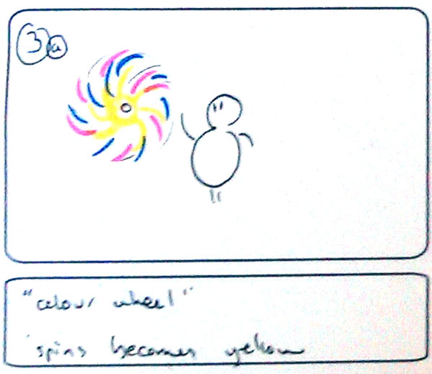  interaction: arm sweep rotates a wheel  graphics: a brightly coloured wheel  sound: wheel of fortune clicking / clapper | 5. Down the road is the sports centre of hip hop breakdancing basket ballers.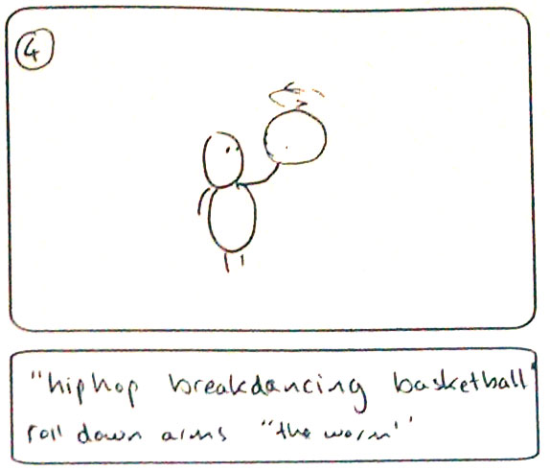  interaction: ball rolls along the arms - 'the worm'  graphics: basketball  sound: sneaker squeak, ball bouncing. music start | 6. The city parks are filled with the summery sounds of BBQ’s cooking and laughter.  for green to go and Sad face for red to stop.  While we have stopped at the lights take notice of the face traffic lights smiling face 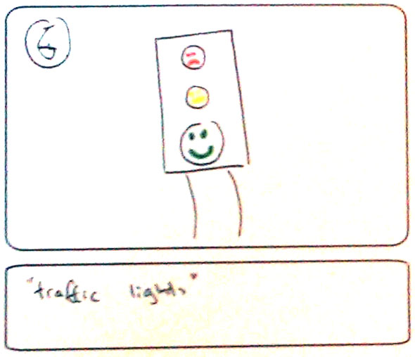  interaction:  graphics: traffic light with separate smiley/hum ho/sad/ faces for green/amber/red  sound: ping - green, lower dun - yellow, clunk - red
7. The music centre is buzzing with beats 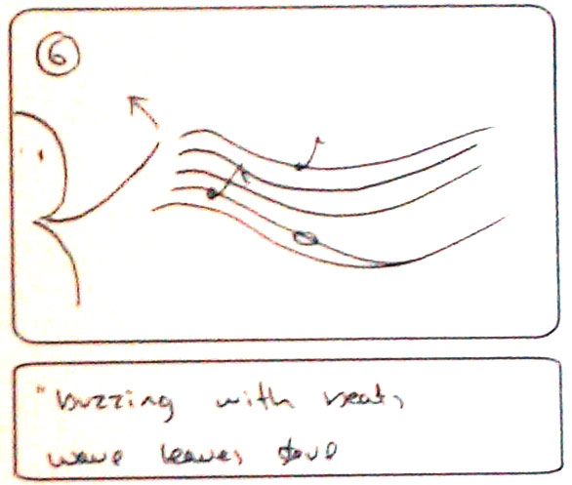  interaction: wave of arm leaves stave with notes int the air  graphics: various notes, minim crotchet quaver etc  sound: heavy drums | 8. and ballerinas pirouetting.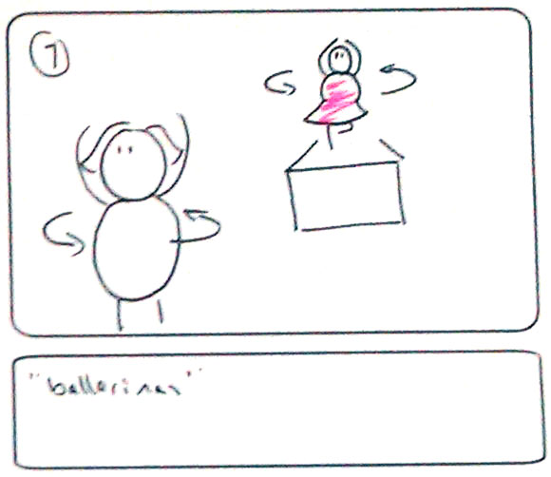  interaction: performer pirouettes and ballerina does likewise  graphics: as flat cut out? or 3D object?  sound: swan lake, oboe, flutes | 9. As the night moves in and clear skies approach you can see the twinking stars and the man on the moon.  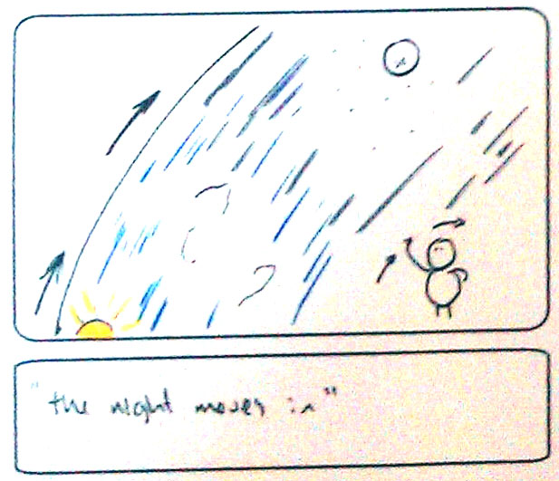  interaction: hand wave spins background from night to day  graphics: large disc which fades from night (stars moon etc) to day (sun clouds etc) like a big 4 seasons pizza  sound: Music changes to lullaby
10.
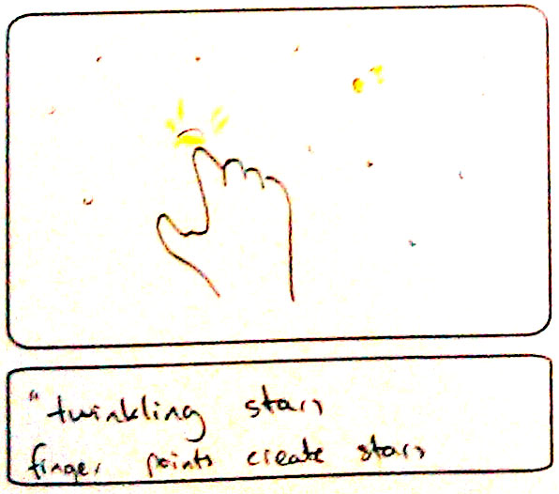
interaction: finger point creates stars
graphics: star
sound: xylophone tinkling

